Backtracking Search

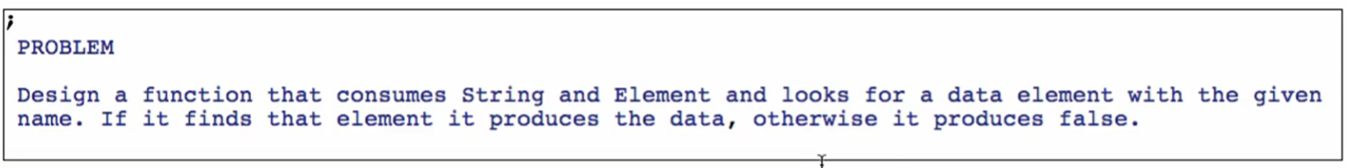

Function definition

**Signature**



* 2 return types!
  + Integer
  + Boolean



* In modern programming languages, false is like **Exceptions**
* https://www.javatpoint.com/exception-handling-in-java#:~:text=What%20is%20Exception%20in%20Java,which%20is%20thrown%20at%20runtime.

**Purpose**

**Stub**

